Unit 6 Assignment: Working with the Unified Modeling Language UML

Use Case Diagram: A use case diagram represents the interaction between users (actors) and a system, specifically outlining the diverse manners in which a system will be used.
Purposes in Modeling: A use case diagram captures the necessary functional requirements of a system; it portrays the interactions of the various user types (actors) with a system of great clarity. This quality enables viewers to understand the system's functionality from the user's perspective.
Role in Object-Oriented Programming Design: In object-oriented design, use case diagrams help to identify and organize system requirements, providing a clear depiction of how a system behaves under different scenarios. They allow for the setting of system boundaries and the visual representation of system interactions.
Class Diagram: A class diagram is a type of static structural diagram in UML. It describes the architecture of a system and its classes within it. These diagrams are considered the foundation for most development methods.
Purpose in Modeling: They're used to structure and envision the system's classes and relationships. From this diagram, one can easily derive the corresponding source code. Many UML tools can do this automatically. The ease with which UML can be turned into real software is one significant reason to use it. Part of the point of teaching UML here is to improve our ability to turn designs into code. Still, a class diagram is a powerful way to envision the system when it's not even built yet.
Differences: Use case diagrams to illustrate system functionality and the interactions the system has with its actors. Class diagrams illustrate the structure of the system and the static relationships among its objects.
Perspective: Use case diagrams to provide the viewpoint of the system's end users. Class diagrams provide the developer's viewpoint.
Design and Development Contributions: Use case diagrams are useful for gathering requirements and making sure all user interactions are represented. Class diagrams are even more powerful when it comes to system development because they provide a detailed blueprint that covers not only the essential systems components but also how they interact.
Class Diagram for an Automobile Dealership

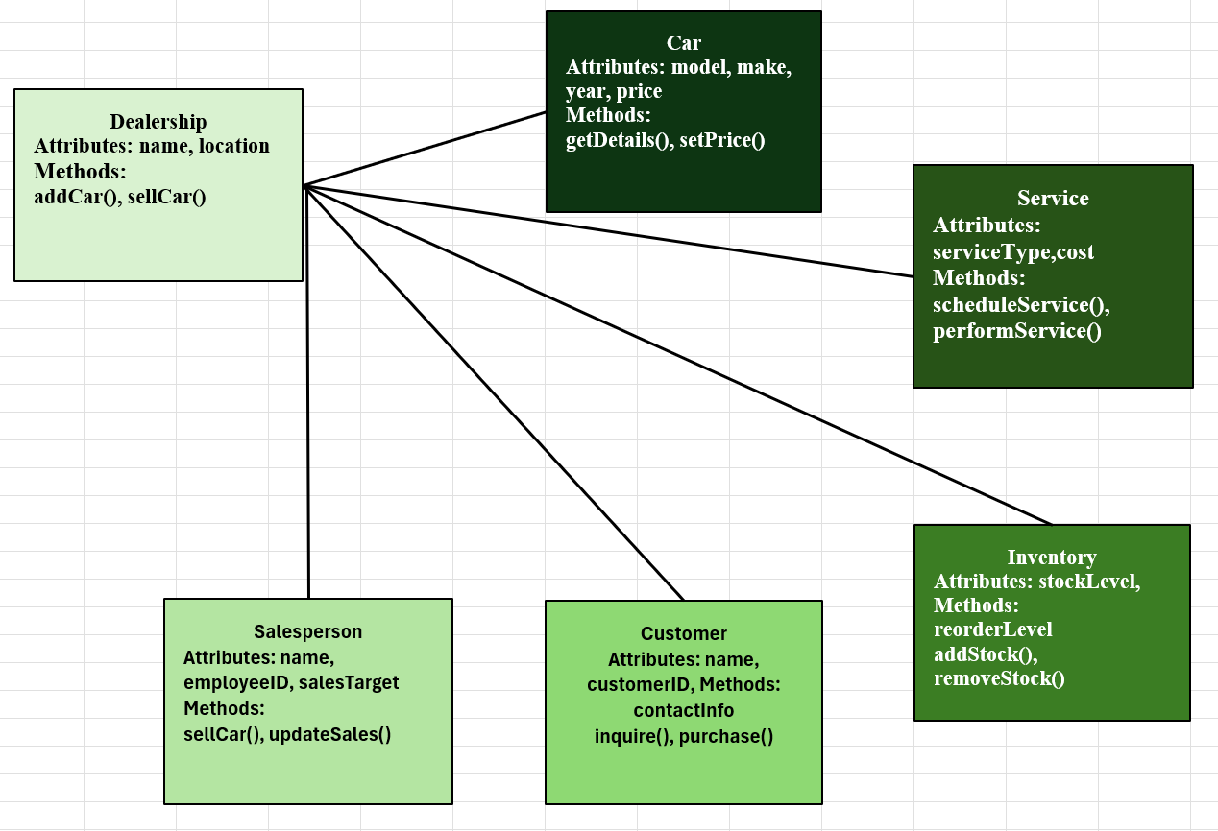
University System Registering Students for Classes

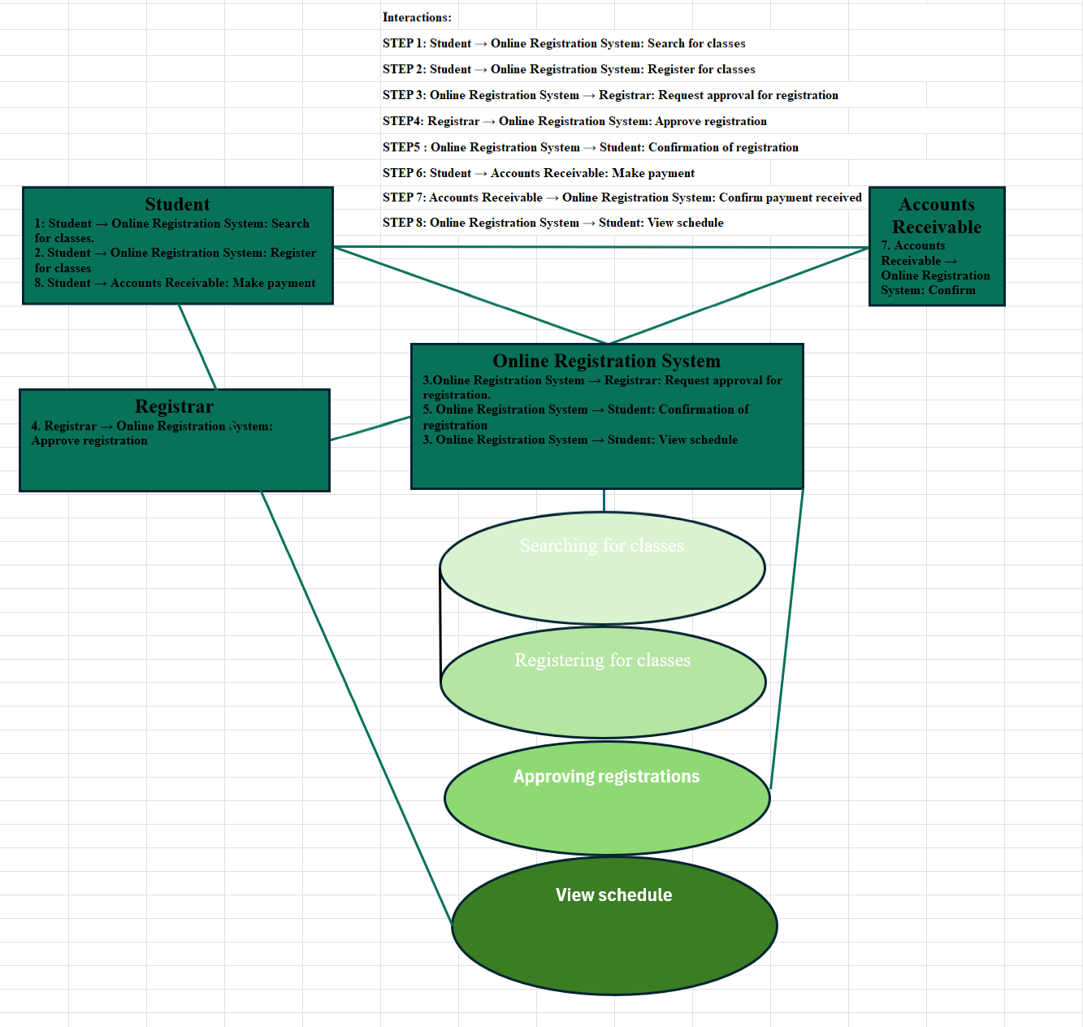
Conclusion

UML diagrams serve as integral tools in object-oriented analysis and design by providing systematic ways of visualizing the functionality and structure of a system. Creating use case and class diagrams of a system aids in comprehending system requirements and architectures, and ultimately allows for a better design and implementation of the system.
Appendix

Automobile Dealership

Dealership: Represents the main entity managing cars and sales. Attributes: name, location. Methods: addCar(), sellCar().
Car: Represents cars in the inventory. Attributes: model, make, year, price. Methods: getDetails(), setPrice().
Salesperson: Represents employees who sell cars. Attributes: name, employeeID, salesTarget. Methods: sellCar(), updateSales().
STEP 1: Student → Online Registration System: Search for classes
STEP 2: Student → Online Registration System: Register for classes
STEP 3: Online Registration System → Registrar:
Request approval for registration
STEP4: Registrar → Online Registration System: Approve registration
STEP5: Online Registration System → Student: Confirmation of registration
STEP 6: Student → Accounts Receivable: Make payment
STEP 7: Accounts Receivable → Online Registration System:
Confirm payment received
STEP 8: Online Registration System → Student: View schedule
Customer: Represents potential buyers. Attributes: name, customerID, contactInfo. Methods: inquire(), purchase().
Service: Represents maintenance services. Attributes: serviceType, cost. Methods: scheduleService(), performService().
Inventory: Represents the stock of cars. Attributes: stockLevel, reorderLevel. Methods: addStock(), removeStock().
University System

Actors Included: Student, Registrar, Online Registration System, Accounts Receivable.
Student: Registers for classes, views schedule, makes payments.
Registrar: Manages student records and approves registrations.
Online Registration System: Handles class search, registration, and scheduling.
Accounts Receivable: Manages billing and payments for registered classes.
Interactions:

